**LAB # 01**

**INTRODUCTION TO STRING POOL, LITERALS, AND WRAPPER CLASSES**

**OBJECTIVE:** To study the concepts of String Constant Pool, String literals, String immutability and Wrapper classes.

## HOME TASKS

1. Write a JAVA program to perform Autoboxing and also implement different methods of wrapper class.

**CODE:**

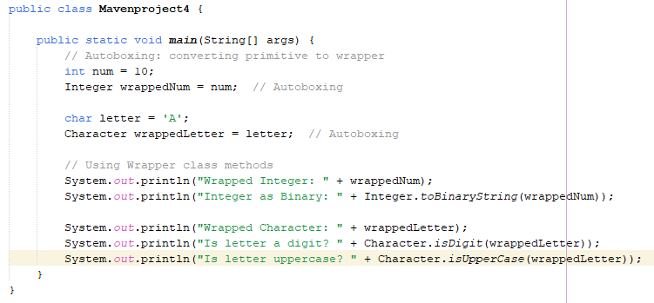

**OUTPUT:**

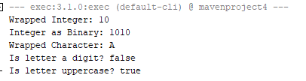

2.Write a Java program to count the number of even and odd digits in a given integer using Autoboxing and Unboxing.

**CODE:**

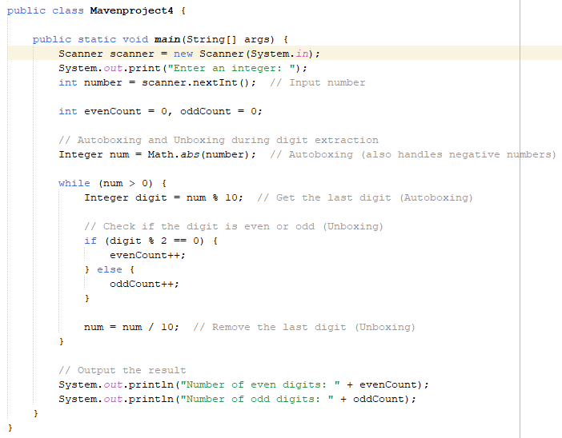

**OUTPUT:**

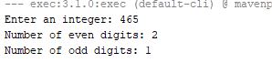

3.Write a Java program to find the absolute value, square root, and power of a number using Math classmethods, while utilizing Autoboxing and Wrapper classes**.**

**CODE:**

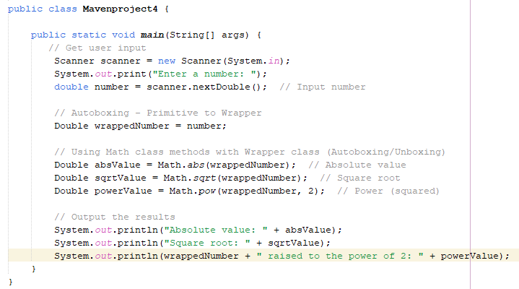

**OUTPUT:**

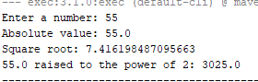

4.Write a Java program to **reverse only the vowels** in a string.

**CODE:**

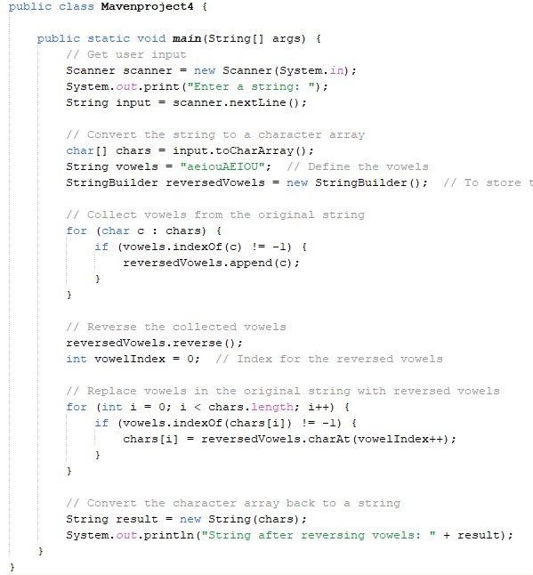

**OUTPUT:**



5.Write a Java program to **find the longest word** in a sentence.

**CODE:**

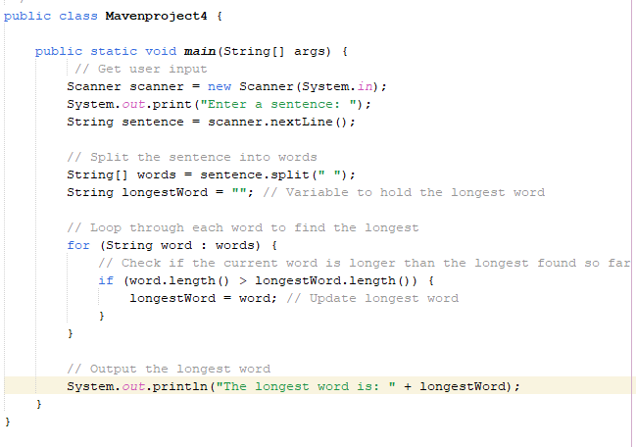

**OUTPUT:**

